SE

2CS504

Practical 6

19BCE230-SACHI CHAUDHARY

19BCE247-DEVANSH SHAH

19BCE248-DHRUVIL SHAH

AIM: Design Class Diagram & CRC index cards for your System.

**Class Diagram:**

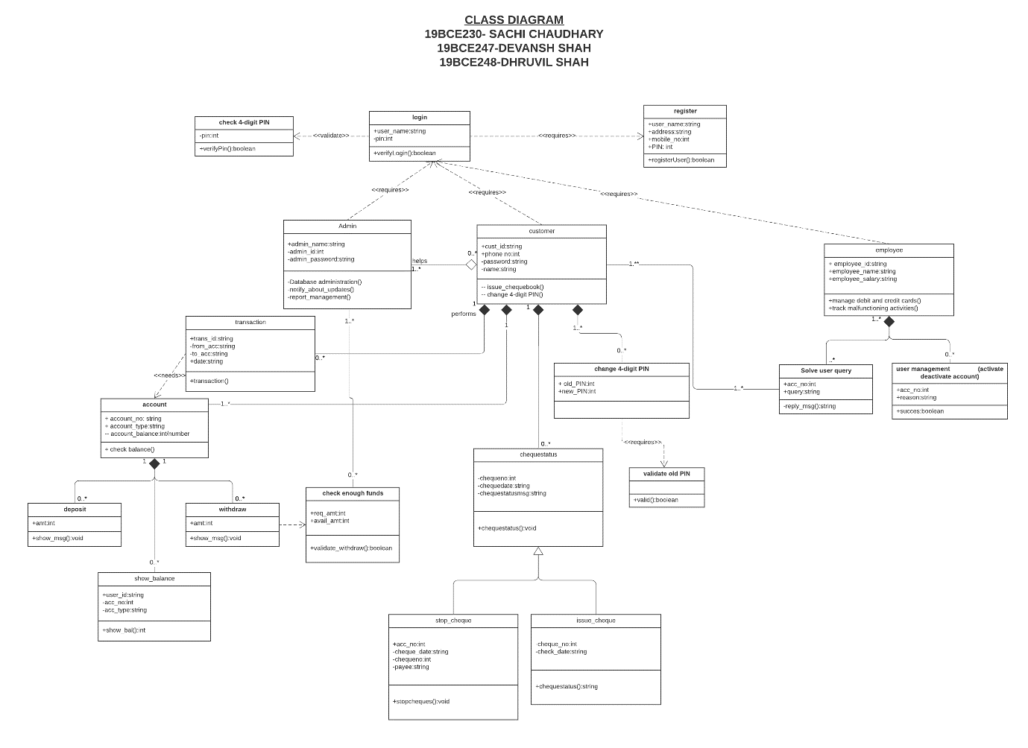

**For Better Visualization visit below link:**

[**Visit Here**](https://lucid.app/lucidchart/6538fa14-71d8-4643-afa7-9dfdfea39614/edit?viewport_loc=913%2C537%2C2573%2C1083%2CHWEp-vi-RSFO&invitationId=inv_4e36169f-07e4-419a-b2cb-6272f6807ba7)

**CRC INDEX CARDS:**

|  |  |
| --- | --- |
| Class name: **Admin** | |
| Responsibilities: | Collaborators: |
| Has unique ID, password for login | Login. |
| Handles database administration. |  |
| Notifies about latest updates. | Employee, customer. |
| Generates reports /stats of the bank. |  |
| Checks for enough fund in bank account of customer while withdrawing and notifies if it is exceeding limits. | Customer. |
| Provide name for registration. | Register. |

|  |  |
| --- | --- |
| Class name: **Customer** | |
| Responsibilities: | Collaborators: |
| Has unique customer ID and password for login. | Login. |
| Provides customer name and phone no. for registration. | Register. |
| Has a bank account. | Account. |
| Can perform different transactions. (deposit/withdraw money) | Transaction. |
| Can issue a new cheque book. |  |
| Can change 4-digit PIN. |  |
| Can check the account balance. |  |
| Ask for any queries. | Solve user query. |
| Apply for a loan. | Employee. |
| Gets reminder about different bank updates and interest due for loan (if applicable). | Admin. |

|  |  |
| --- | --- |
| Class name: **Employee** | |
| Responsibilities: | Collaborators: |
| Has unique ID and password for login. | Login |
| Provides name, salary, etc for registration. | Register. |
| Manages credit and debit card transactions of the customer. |  |
| Track malfunctioning activities. |  |
| Manages account of user(activate/deactivate). |  |
| Solve user queries. | Customer. |
| Handles loan application of customer. |  |

|  |  |
| --- | --- |
| Class name: **Login** | |
| Responsibilities: | Collaborators: |
| Inputs username and PIN for login. | Admin, customer, employee. |
| Checks for valid 4 digit- PIN | Check PIN. |
| Checks that username is already registered. | Register. |

|  |  |
| --- | --- |
| Class name: **Register** | |
| Responsibilities: | Collaborators: |
| Inputs username and PIN for login. | Admin, customer, employee. |
| Checks for valid 4 digit- PIN | Check 4-digit pin |

|  |  |
| --- | --- |
| Class name: **Check 4-digit pin** | |
| Responsibilities: | Collaborators: |
| Checks for valid 4 digit- PIN | Login, Register |

|  |  |
| --- | --- |
| Class name: **Account** | |
| Responsibilities: | Collaborators: |
| Keep track of each user activities | Customer |
| All Transaction history are recorded | Transaction |
| Give various ways of performing transaction | Deposit, Withdraw, Show Balance |

|  |  |
| --- | --- |
| Class name: **Deposit** | |
| Responsibilities: | Collaborators: |
| Deposit amount | Account |

|  |  |
| --- | --- |
| Class name: **Withdraw** | |
| Responsibilities: | Collaborators: |
| Helps to withdraw money | Account |
| After each withdrawal notifies user |  |
| Checks for sufficient amount | CheckEnoughFunds |

|  |  |
| --- | --- |
| Class name: **CheckEnoughFunds** | |
| Responsibilities: | Collaborators: |
| Helps when user need to withdraw money |  |
| Returns whether transaction can be performed or not | Admin |

|  |  |
| --- | --- |
| Class name: **ChequeStatus** | |
| Responsibilities: | Collaborators: |
| Has Cheque no |  |
| Has Cheque date |  |
| Issuing Cheque | IssueCheque |
| Stop Cheque transaction in case of any query | StopCheque |
| Notifies about Status |  |

|  |  |
| --- | --- |
| Class name: **StopCheque** | |
| Responsibilities: | Collaborators: |
| Tracking of misleading | ChequeStatus |
| Has Cheque date, Cheque No |  |
| Restricted to Only Employees | Employee |
| Informing before doing any action to customer |  |

|  |  |
| --- | --- |
| Class name: **IssueCheque** | |
| Responsibilities: | Collaborators: |
| Issuing Cheque | ChequeStatus |
| Has Cheque date, Cheque No |  |
| Informing after cheque issued |  |

|  |  |
| --- | --- |
| Class name: **SolveUserQuery** | |
| Responsibilities: | Collaborators: |
| Directly in Contact with Customer |  |
| Should be private between two parties | Customer, Employee |
| Respond as soon as possible |  |

|  |  |
| --- | --- |
| Class name: **ActivateDeactivateAccount** | |
| Responsibilities: | Collaborators: |
| Removing All entries within on book as well as from hosted database | Admin, Employee |
| Must Know the reason for the same from customer |  |
| Convincing the Customer not to deactivate unless it is serious matter of concern |  |